Position: [Home](http://www.seekic.com/) > [Circuit Diagram](http://www.seekic.com/circuit_diagram/) > [Signal Processing](http://www.seekic.com/circuit_diagram/Signal_Processing/) > Vackar VFO 2

[](http://www.pcbway.com/)

**Signal Processing**

**Vackar VFO 2**

Published:2013-1-3 20:25:00 Author:muriel | Keyword: Vackar VFO | From:SeekIC

[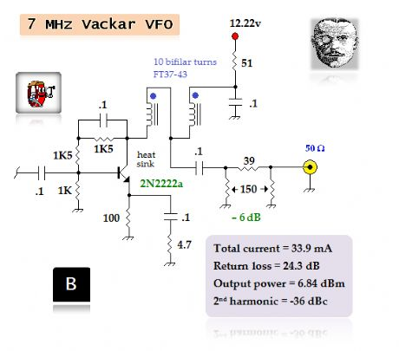](http://www.seekic.com/uploadfile/ic-circuit/201313202548784.jpg)